Ideation Phase
Define the Problem Statements

Date | 19 January 2026
Team ID | LTVIP2026TMIDS83701
Project Name | Smart Sorting: Transfer learning for identifying Rotten Fruits and Vegetables
Maximum Marks | 2 Marks

Smart Sorting Transfer Learning – Problem Statement:
The accurate identification and classification of fresh and rotten fruits and vegetables are essential for ensuring food quality, reducing waste, and maintaining safety standards in supply chains and retail markets. Traditional manual inspection methods, while commonly used, are time-consuming, labor-intensive, and prone to human error due to inconsistencies in judgment, fatigue, and varying environmental conditions. Existing automated sorting systems often struggle with accurately detecting subtle spoilage patterns, color variations, texture changes, and diverse produce types under different lighting and background conditions.
There is a growing need for an intelligent, automated smart sorting system that leverages advanced transfer learning techniques and deep learning models to accurately identify and classify rotten and fresh fruits and vegetables. Such a system would enable efficient, scalable, and real-time quality assessment, minimizing food waste, improving operational efficiency, and enhancing overall food safety in agricultural and commercial environments.
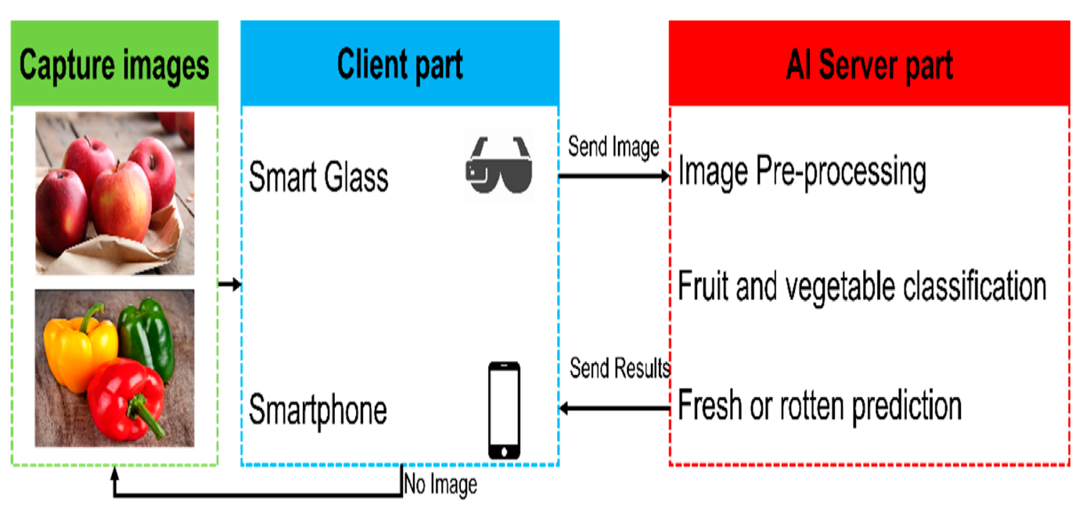
Reference: https://miro.com/templates/customer-problem-statement/

Example: 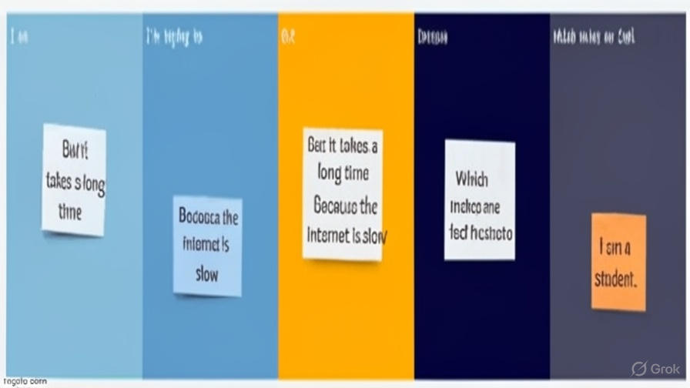

PS | I am (Customer) | I’m trying to | But | Because | Which makes me feel
PS-1 | I am a food quality inspector and supply chain manager responsible for maintaining product standards and minimizing waste. | I’m trying to accurately identify and separate fresh and rotten fruits and vegetables to ensure quality and safety. | But the manual inspection and sorting process is slow, inconsistent, and prone to human error. | Because existing systems lack advanced automation and struggle to detect subtle spoilage patterns under varying lighting and environmental conditions. | Which makes me feel frustrated and concerned about product losses, reduced efficiency, and potential customer dissatisfaction.

